|  |
| --- |
| The Noise |
| A Client Overview |
| [Type the document subtitle] |

|  |
| --- |
| Jeffrey Price  5/1/2013 |

Contents

The Log in Window 1

The Registration Window 2

The File Selection Window 3

The Settings Window 4

The client’s side of the program consists of four windows. One for log in to the server, one for registration to the server, and the third window displays the music files and when the file is selected and doubled click it open up the last window. The last windows play the music which was provided by Derek.

# The Log in Window

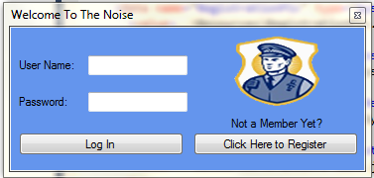

The log in window is for users that have already reregistered with the server. After the user has entered their username and password in the correct fields and click the log in button the server will then check the information entered.

If the information entered is successful checked, the file directory window will open.

If the information entered is not successful checked, an error window will pop up informing the user that either the User Name or Password entered is incorrect.

The click here to register button if clicked will open a register window for the user to fill out the proper information in order to be add to the server’s database.

# The Registration Window

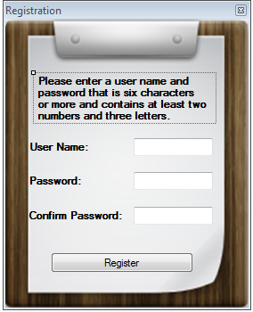

The Registration window is where new users can register. A user name is the first piece of information required from the user. Next is a password that is six characters or more and has at least two numbers and three letters. If those requirements are not meet a error window pops up for each condition that is not meet.

The confirm field is to make sure the user has enter the correct desired password.

# The File Selection Window

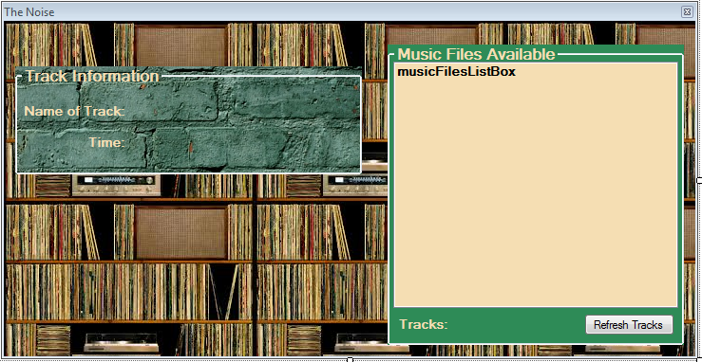

This window allows the user to select files from the Music Files Available window. When the selected file is selected the information about the audio file will appear in the track Information group box. The Refresh tracks button updates the tracks that are being stored in the data base. If new tracks are added or old tracks deleted it will show that result in the Music Files Available window. When a file is double click it will pop up Derek’s window and plays the music.

# The Settings Window

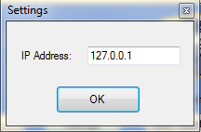

The settings window is used to set the IP Address.